**Form 45/FO/IS/31 REGISTRATION WITH INVESTOR SERVICES DEPARTMENT**

1. Name of the Enterprise…………………………………………………………………………………………………………………………
2. BOI Registration Number / / /
3. Tax Identification Number (TIN)
4. Value Added Tax Number (VAT) -

6. Address (As per TIN / VAT Certificate)

.………………………………………………………………

……………………………………………………………….

……………………………………………………………….

……………………………………………………………….

…………………………………………………………….

Authorized Signatory of Enterprise Chairman / Managing Director

Please forward the following documents for registration

5. Address of Enterprise

(Location of project as indicated in the agreement)

………………………………………………………………………….

………………………………………………………………………….

……………………………………………………………………….....

………………………………………………………………………….

7. Contact Person: …………………………........................

Designation: ……………………………..

Off. Tel: …………………………. Fax: ……………………………….

E-Mail: …………………………...

………………………………………

Date

Office Use

Warehouse Code

BOI – agreement (Original)

BOI Investment approval letter (Original)

VAT / TIN Certification (original) with a photocopy

Approval for first Import Approval for first Export

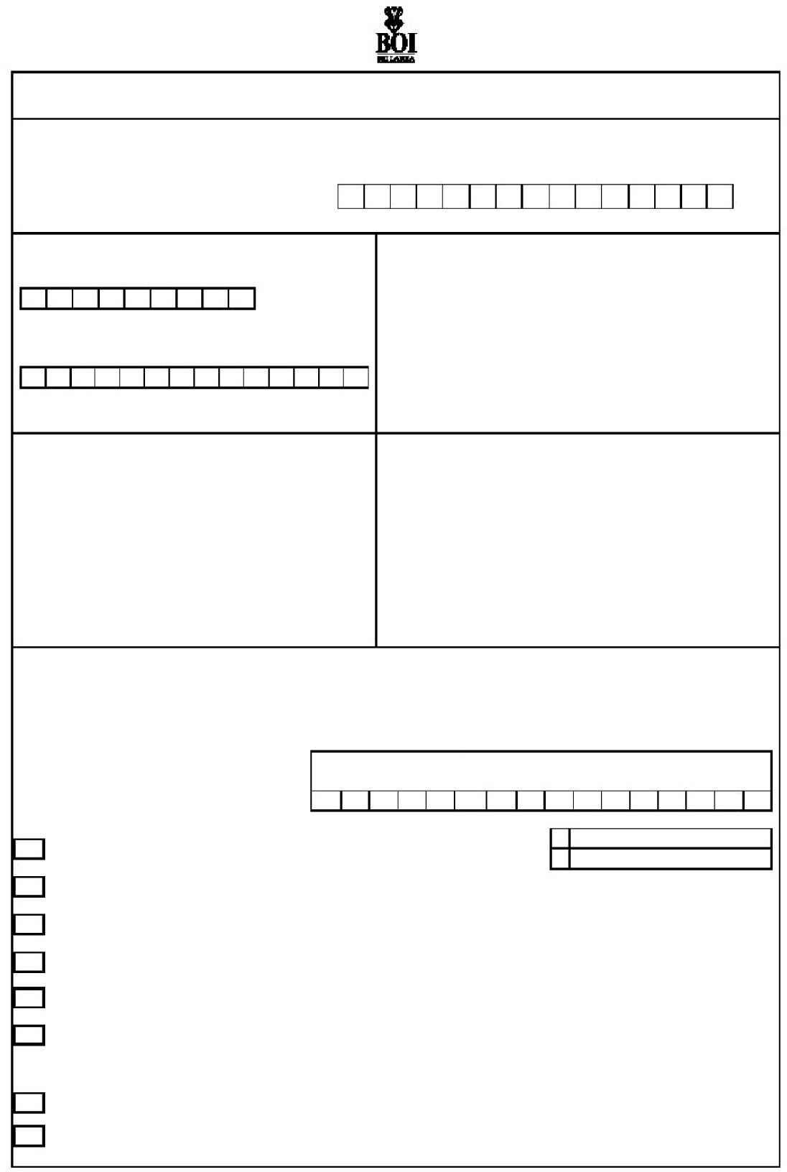

List of items approved by the Investment Department to be imported by enterprise BOI Registration Certificate (original)

List of authorized signatories approved to sign import / export cusdecs (names, designations, NIC/Passport numbers and signatures of three personnel) – 02 originals certified by the Chairman / Managing Director of the enterprise

A certified copy of Form 1 sent to the registrar of companies

A certified copy of Form 2A (Certificate of Incorporation) sent to the registrar of companies.