## Form 45/FO/IS/05

(To be submitted in 3 copies)

# BOARD OF INVESTMENT OF SRI LANKA

For office use

Senior Deputy Director – Investor Services Board of Investment of Sri Lanka

# APPLICATION FOR TEMPORARY EXPORT/RE-EXPORT OF GOODS IMPORTED ON DUTY FREE BASIS

1. Name & Address of Enterprise (Exporter)

…………………………………………..

…………………………………………..

1. Name & Address of the Consignee

……………………………………

………………................................

Tin No………………………………….. Tin No……………………………..

1. Nature of Business: ……………………………………………………………………………………………………….
2. Details of duty free imports (If space is insufficient, please attach a separate sheet) (**Please attach documentary evidence of the Import**)
   * Name and country of the supplier: …………………………………………………………………………….

Import Cusdec No. & Date

Description of the Items HS Code Qty. Imported CIF Value (FC) Terms of Payment

NFE/FE

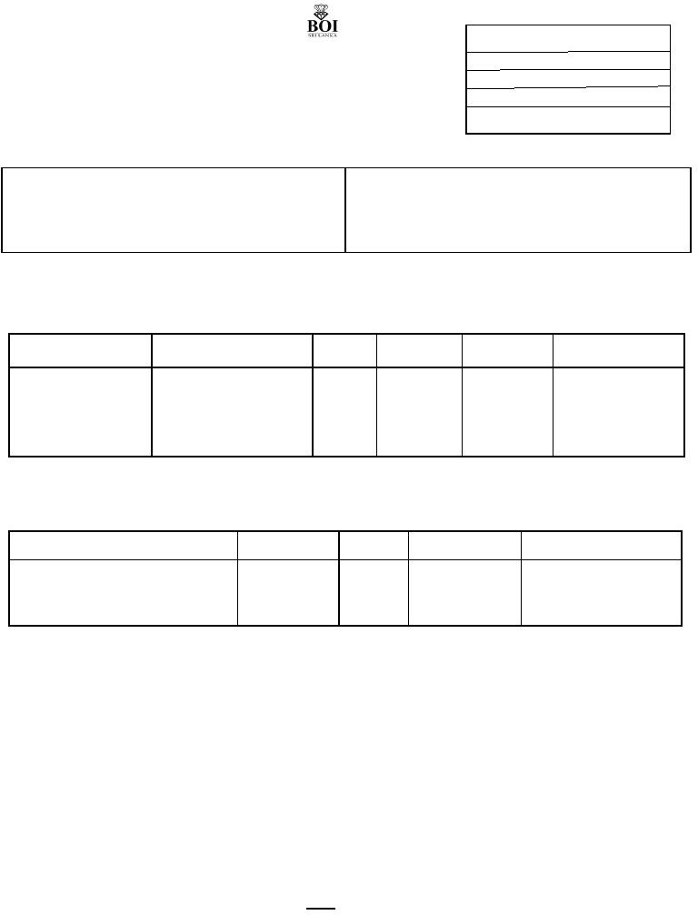

1. Reason / Purpose for Temporary exports/ Re-exports (**Please specify and attach special approvals where applicable**)
2. Details of item/s to be Temporary exported/Re-exported (If space is insufficient, please attach a separate sheet)

Description of the items HS Code Qty. FOB Value (FC) Terms of Payment (NFE/FE)

We hereby declare that the above particulars are true and correct and we agree to abide by the under mentioned conditions as applicable thereto.

………………………………………………………………..

Authorized signatory of the enterprise with name & the stamp Date…………………………

## APPROVAL OF THE BOI

Temporary export/Re-export of goods is approved subject to the conditions stipulated below.

1. Export CUSDEC to be submitted to the relevant Investor Services Department at the time of re-export.
2. Temporary exports/Re-export to be effected within a period of one month from the date of this approval. Short/Partial shipments are not allowed.
3. Payment between re-exporter & consignee, as and when applicable to be effected in foreign currency through the normal banking system.
4. Temporary exports/Re-export is subject to verification by the relevant verification unit of the BOI.
5. In the event of temporary export/re-import of goods are re-imported to Sri Lanka, relevant temporary export/re-export documents should be attached to the Import Documents for approval.

Checked by: ………………………………….. Approved by: ………………………………

## (EA/AD) (SDD/DD/ADD)

*Note; Hand written applications will not be accepted

CC: Director – Bonds – Sri Lanka Customs

BOI file copy