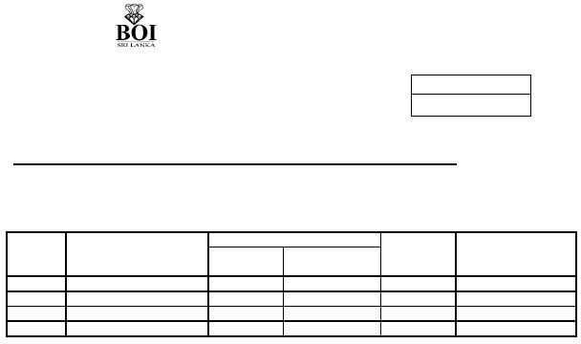
BOARD OF INVESTMENT OF SRI LANKA
FORM 45/FO/IS/30
(To be submitted in 07 copies)
Senior Deputy Director (Investor Services) Board of Investment of Sri Lanka
For office use
Ref
Date
APPLICATION FOR THE SALE OF FINISHED PRODUCTS IN THE LOCAL MARKET
1.
2.
3.
Name and Address of the Enterprise : ……………………………………………
Tax Identification No (TIN No) : ……………………………………………
Particulars of the finished items to be sold ………………………………………………

Quantity to be sold
Item No Description of the item As per HS
Supplementary Quantity
Invoice No Value in Rupees
4. Maximum limit of Local Sales approved as per the agreement ……..…………………..………
We hereby request your permission for the sale of above mentioned finished products in the local market and affirm you that the quantity we requested is within the permissible limit of local sale as per the provisions of the agreement entered in to with BOI.

………………………………………………………………..
Authorized signatory of the enterprise with name & the stamp Date…………………

APPROVAL OF THE BOI
The above local sale is approved subject to the conditions stipulated below.
- Payment of relevant Customs duty
  - On the value of the imported raw material component of the finished products.

  - On the Value of the finished products. (Inapplicable clause has been deleted)
And other applicable levies as determined by the Sri Lanka Customs and submission of documentary evidence pertaining thereto to the Investor Service Department prior to removal of the items.

- Applicable charges inclusive of VAT as per service charge schedule of BOI for each removal.
- The transaction is subject to verification by BOI/Sri Lanka Customs .
- The removal of the items are permitted to be effected only during 8.30am to 4.30pm on week days.
- This local sale should be finalized within a period of one month from the date of this letter. If the local sale is not effected this application should be surrendered to the relevant service centre within three days from the date of expiry.

- Settlement of any outstanding dues, if any, to the BOI prior to removal of above items.

..………………………………………………………………………… FOR SENIOR DEPUTY DIRECTOR (INVESTOR SERVICES) BOARD OF INVESTMENT OF SRI LANKA
CC Director Customs, Sri Lanka Customs.
Commissioner ( VAT)- Dept,of Inland Revenue, Colombo 02. Superintendent of Customs, Sri Lanka Customs.
Deputy Director – Internal Audit. Deputy Director – Verification.

